**Helpful Information**

**Normal EKG Complex**

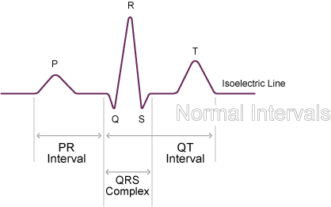

**Normal intervals (in seconds)**

* **PRI** 0.12 to 0.20
* **QRS** 0.08 to 0.10
* **QT** 0.36 to 0.44

**EKG Graph Paper Measurements** (using a 6 second strip)